**RPI 4B Different Communications**

Enable & use UART on RPI 4B:

1. <https://www.abelectronics.co.uk/kb/article/1035/serial-port-setup-in-raspberry-pi-os>
   1. Serial port setup
2. <https://www.youtube.com/watch?v=oevxqPk78sM&t=1s>
   1. Minicom Setup
   2. Sudo apt-get install minicom
   3. Minicom -b baud rate -o -D port name 🡪 Minicom -b 115200 -o -D /dev/ttyAMA0
   4. For testing UART, short the RX and TX pins and then use the following 2 commands:
      * Echo “hello world” > dev/ttyAMA0
      * Minicom -b 115200 -o -D /dev/ttyAMA0

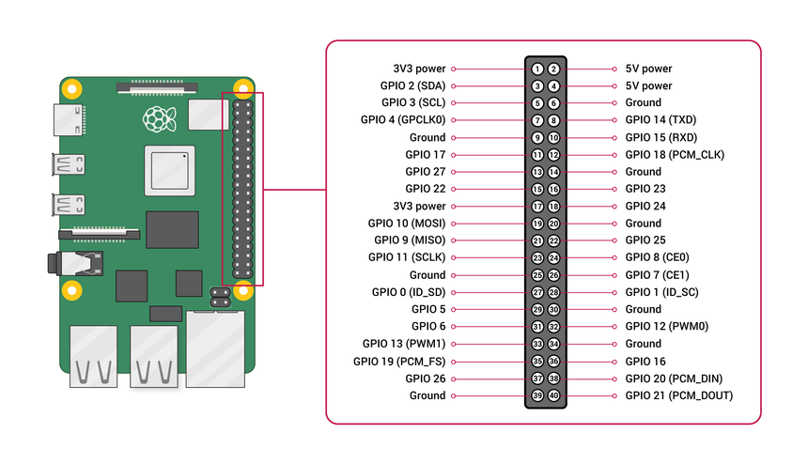

Using UART on ESP32:

1. <https://circuits4you.com/2018/12/31/esp32-hardware-serial2-example/>

